TOPIC 5.8 : HUFFMAN DECODING
Problem Statement
Given a Huffman Tree and a Huffman encoded string, decode the string to get the original message.
Test Case 1
Input:
n = 4
characters = ['a', 'b', 'c', 'd']
frequencies = [5, 9, 12, 13]
encoded_string = '1101100111110'
Output: "abacd"
Test Case 2
Input:
n = 6
characters = ['f', 'e', 'd', 'c', 'b', 'a']
frequencies = [5, 9, 12, 13, 16, 45]
encoded_string = '110011011100101111001011'
Output: "fcbade"
Aim
To write a program that decodes a Huffman encoded string using the given Huffman Tree constructed from characters and frequencies.
Algorithm
- Start
- Construct the Huffman Tree using characters and frequencies (same as Huffman Coding)
- Initialize an empty string for the decoded message
- Traverse the encoded string bit by bit:
  - Move left if the bit is 0
  - Move right if the bit is 1
  - When a leaf node is reached, append the character to the decoded message and reset to the root
- Return the decoded message
- Stop
Input and Output
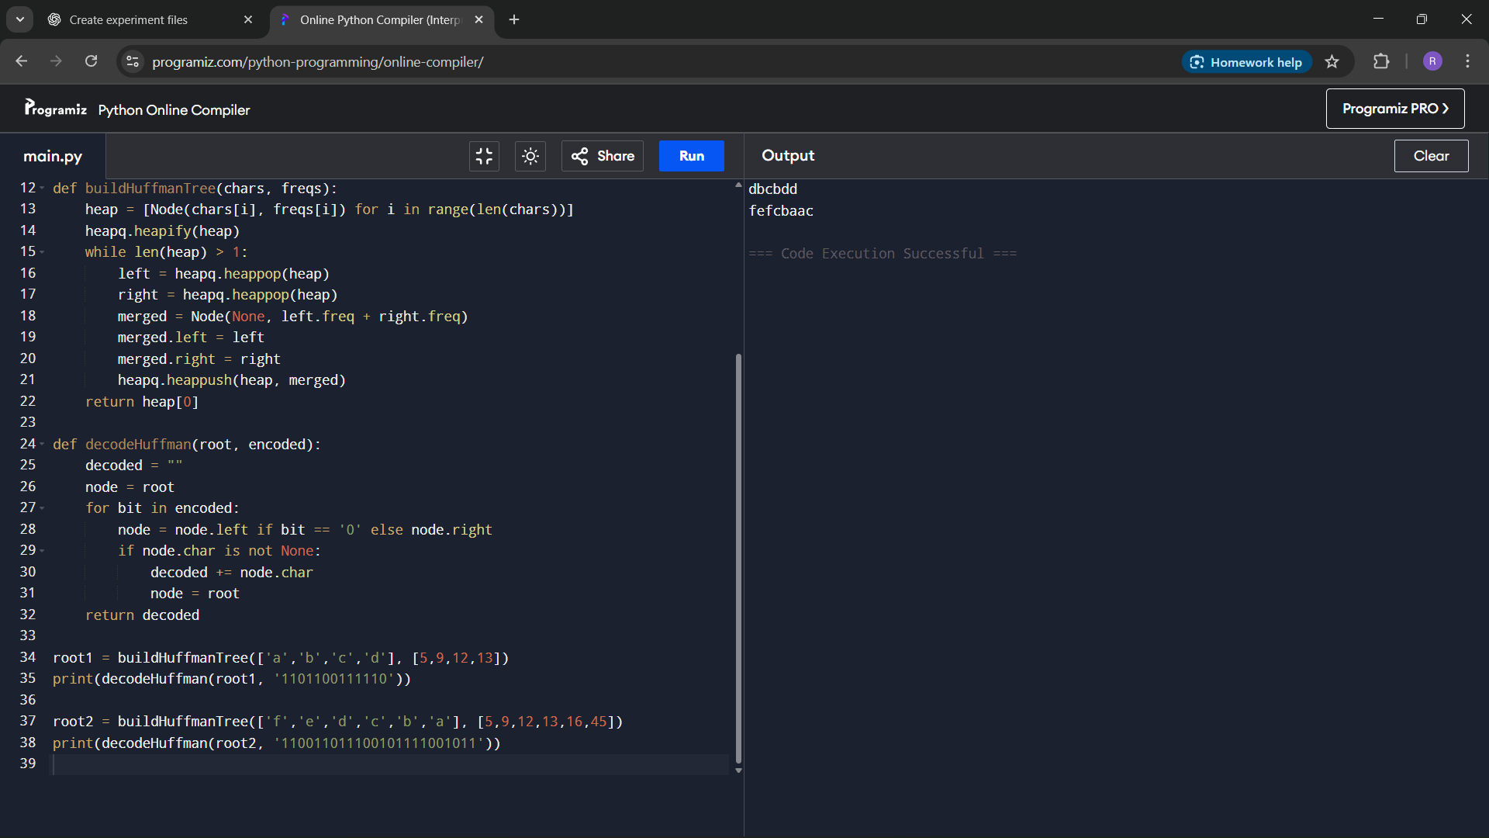
Result
The program successfully decodes a Huffman encoded string using the constructed Huffman Tree.
Performance Analysis
Time Complexity: O(m + n log n), where n is the number of characters and m is the length of the encoded string
Space Complexity: O(n) for the Huffman Tree

